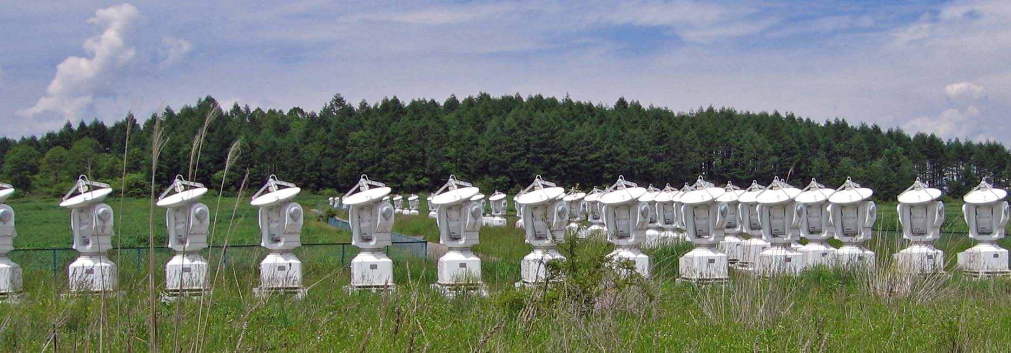HOW TO BUILD YOUR OWN

RADIO TELESCOPE

## cover strip

Percival Andrews

## Blank page

## Fourth edition 2013

First edition 2007

Copyright ©text

Percival Andrews, 2007-2013

Copyright ©photographs, diagrams, and illustrations

Percival Andrew, 2007-2013, except where otherwise credited

All rights reserved. Without limiting the rights under copyright reserved above, no part of this publication may be transmitted in any form without the prior written permission of Percival Andrews

*The radio telescope described in the book is very low power and therefore quite safe. The following precautions will ensure trouble-free operation:*

*1. Be aware that the antenna could be a hazard during a thunderstorm. You should disconnect the antenna during a thunderstorm, especially if it is outdoors*

*2. The solar storm radio telescope connects to a PC via a sound card. You can make use of an inexpensive external USB sound card if you don't want to connect anything directly to your PC*

This book contains instructions, schematics, and computer programs for use in amateur radio telescope and computer interface projects. The content of the book is to be considered experimental only, and the authors make no claims as to the functionality of actual working models made from the instructions in this book. The reader is expressly warned to consider and adopt all safety precautions that might be indicated by the activities herein and to avoid all potential hazards. By following the instructions contained herein, the reader willingly assumes all risks in connection with such instructions.

Information contained in this book has been obtained from sources believed to be reliable. However the author does not guarantee the accuracy or completeness of the information contained herein, and the author shall not be responsible for any errors, omissions, or damages arising out of the use of this information.

Thank you very much indeed for your interest in my book. I wish you every success with your radio telescope project. If you have any questions or comments about the book, please don’t hesitate to contact me. I look forward to hearing from you.

With warm regards,

## Percival Andrews

[percival.andrews@gmail.com](mailto:percival.andrews@gmail.com)

[http://www.radiotelescopebuilder.com](http://www.radiotelescopebuilder.com/)

# Contents

|  |  |  |
| --- | --- | --- |
| 1 | Why build a radio telescope? |  |
| 2 | Introducing the Solar Storm Radio Telescope (SSRT) |  |
| 3 | What you’ll need to build the SSRT |  |
| 4 | Finding a suitable radio transmitter |  |
| 5 | Building the on-board electronics |  |
| 6 | Building the antenna |  |
| 7 | Installing the radio telescope |  |
| 8 | Installing the PC software and finding the signal |  |
| 9 | Logging the radio telescope data |  |
| 10 | Optimizing the performance of the radio telescope |  |
| 11 | Interpreting the radio telescope signal |  |
| 12 | The SSRT online network |  |
| 13 | Keeping a record |  |
| A1 | System diagram |  |
| A2 | Electronic schematic diagram |  |
| A3 | Electronics parts list |  |
| A4 | Signal generator |  |
| A5 | Data collection for the AAVSO |  |

# Blank page

# 1. Why build a radio telescope?

## CMB discovery telescopeRadio telescopes are critical for science and astronomy

It was an experimental radio antenna operating in New Jersey in 1964 that first detected the Cosmic Microwave Background Radiation. These microwaves, permeating through space in all directions, provided the original piece of experimental evidence for the theory of the Big Bang. The discoverers, Arno Penzias and Robert Wilson, received the Nobel Prize for Physics in 1978 for their finding.

Fig 1.1. The experimental radio antenna that first detected the Cosmic Microwave Background Radiation in 1964 and won Arno Penzias and Robert Wilson the Nobel Prize.

This is just an example, of course, and whilst I’m not suggesting that your radio telescope project is going to lead to another Nobel Prize, I can guarantee that you are about to embark on an exciting journey of learning and discovery.

## Solar storms are an interesting subjects study

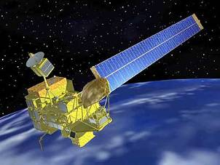Sunspots and solar storms have some surprising effects here on earth. A study of agricultural markets in the 17th century showed that crop yields were higher and grain prices lower during years with high sunspot activity. It’s still a mystery how this can happen, but sunspots must clearly influence the weather. A study of the Texas electricity market in recent years showed that solar storms reduced the efficiency of transformers in the electricity distribution grid and increased the price of electricity. Events can be more dramatic. On October 29th, 2003 the $450 million Japanese weather satellite Midori 2 was knocked permanently out of action by a solar storm, and on December 6th, 2006 the Global Positioning Satellite (GPS) system was disrupted by a solar storm.

Fig 1.2. The Midori 2 satellite before being disabled by a solar storm. Credit JAXA

In the next chapter I’ll explain how the easy-to-build Solar Storm Radio Telescope that I describe in this book will let you monitor these events as they happen. You’ll build up your own records of the solar storms that rage in the atmosphere above your home, and be able to share that information with others automatically over the internet. First let’s look at some of the phenomena that are associated with solar storms.

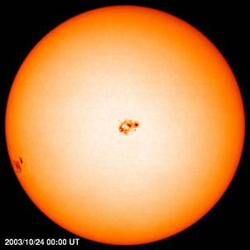Sunspots

These are dark blotches on the surface of the sun that are cooler than their surroundings. They are caused by changes in the convection currents that bring the sun’s heat from the interior to the surface.

Solar flares

Solar flares occur when magnetic field lines on the surface of the sun that have become compressed and distorted in the region of a sunspot suddenly reconnect with an explosive release of energy. Temperatures in the region reach more than 10 million Kelvin, and a burst of X-rays is shot out into space over a period of several minutes.

Fig 1.3. Sunspot are cooler regions that appear as dark blotches on the surface of the sun.

Credit: SOHO

Usually solar flares pass away harmlessly into space, but occasionally the Earth will lie in the line of fire. It takes about 8 minutes for the X-rays to travel across the 150 million km between the Sun and the Earth. When the X-rays hit the ionized top layer of the Earth’s atmosphere, the ionosphere, they create an electrical disturbance. The arrival of these powerful X-rays and the dynamism in the atmosphere that they create is known as a solar storm.

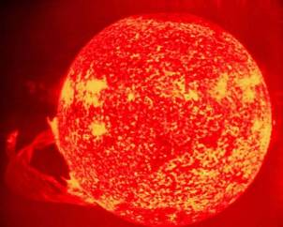

Coronal mass ejections

These are sudden ejections of charged particles from the Sun’s upper atmosphere (the corona). In a typical coronal mass ejection about 10 billion tons of matter (mainly electrons and protons) are fired away into space. Like solar flares, coronal mass ejections are likely caused by rapid reconfigurations of the magnetic field lines on the surface of the sun. Coronal mass ejections create solar storms when the Earth lies in the line of sight of the ejected particles.

Fig 1.4. A solar flare driven by magnetic fields send X-rays into space. Credit NASA

Solar flares and coronal mass ejections are closely linked to the 11 year cycle of sunspot activity. At solar maximum there may be several solar flares or coronal mass ejections somewhere on the Sun every day. At solar minimum there may be weeks between these events. The last solar maximum was in 2001. Scientists have predicted that the next solar cycle will start its build up in late 2007 or early 2008, and may be 30-50% more intense than the last cycle. So there’s never been a better time to build a radio telescope.

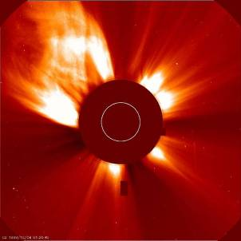

# Blank page

Fig 1.5. A coronal mass ejection. The disk of the Sun is obscured by the camera. Credit SOHO

# 2. Introducing the Solar Storm Radio Telescope (SSRT)

## The SSRT monitors solar storms indirectly by using radio waves to sense sudden disturbances in ionosphere (SID’s)

The ionosphere is an ionized layer in the atmosphere roughly 50-600 km above the Earth’s surface. Its ionization is caused by incoming UV and X-ray radiation from the sun. The degree of ionization increases with the amount of solar radiation received, and therefore tends to depend on the latitude, the season, and the time of day. Ionization is also dramatically affected by exceptional events such as solar flares and coronal mass ejections.

Fig 2.1. Different degrees of ionization in the ionosphere above the Earth shows the dependence on incoming solar radiation.

Credit NASA

The ionosphere is excellent propagator of radio waves. Short wave communications such the BBC World Service are broadcast across the globe thanks to the ability of the ionosphere to carry radio waves beyond the transmitter’s line of sight. The strength of the propagation by the ionosphere depends on the degree of ionization in quite complex ways that we will examine more carefully in chapter 10, but the essential point is that short terms changes in the degree of ionization can be detected by monitoring the changing power of a distant radio signal that is being carried through the ionosphere, thus indicating the occurrence of solar storms.

The kind of radio signal that we would like to monitor is ideally available all over the world, receivable at long range, and transmitted at constant power. Fortunately such a system exists. It is the Very Low Frequency (VLF) submarine communications network. The VLF band at 3-30 kHz is used for submarine communications because only such low frequencies can penetrate through sea water to be picked up by submerged submarines. There are several dozen naval transmitters in use around the world. One of the most powerful is the 24 kHz transmitter at 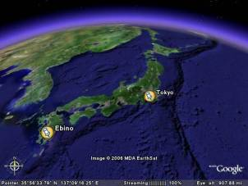Cultler, Maine, USA. Another powerful transmitter is the 22.2 khz transmitter at Ebino, Kuyshu, Japan that I monitor. There are several more in Europe and chapter 4 has an up-to-date list.

Just to reassure you, it is perfectly legal to tune into these signals – the transmissions are coded and our simple equipment just measures the strength of the signal and cannot eavesdrop on secret communications. Nobody official or in uniform is going to call on you when you start operating your radio telescope.

Fig 2.2. VLF transmissions from Ebino, Kuyshu, Japan propagated by the ionosphere can be received 900 km away in Tokyo. Credit: Google Earth

## The SSRT produces a diurnal trace that can be interpreted to reveal events such as solar storms

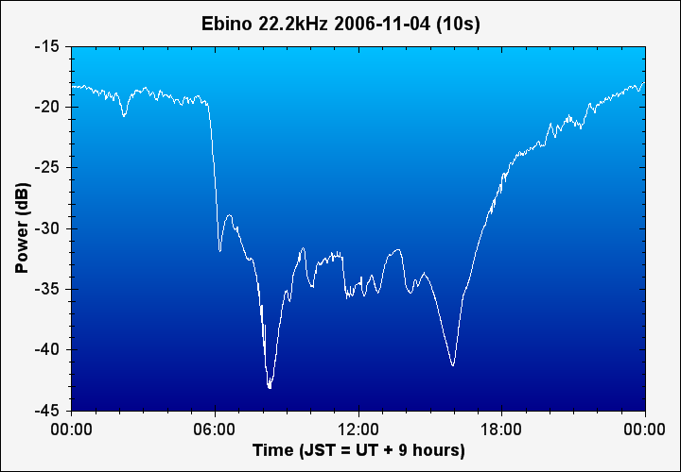Let’s take a quick tour of some typical traces produced by the SSRT and see how they alert us to solar storms. Figure 2.3 shows a typical signal received from my SSRT on a quiet day. The local time at the site of the radio telescope in Tokyo, Japan is on the x-axis. The power of the received signal from the VLF transmitter at Ebino, 900 km away to the south-west is shown on the y-axis. The scale is in decibels, which is simply a logarithmic scale of power relative to some arbitrary level.

Fig 2.3.

Output from my SSRT on a quiet day. The main feature is the diurnal pattern caused by the daily cycle of solar UV irradiation  
on the ionosphere.

The distinctive outline of the trace is caused by the daily cycle of day and night. During the daytime UV radiation from the sun increases the ionization of the ionosphere, but after the sun has set, electrons and ions start to recombine and ionization decreases. Perhaps counter-intuitively, the effect of the increased daytime radiation and ionization is to reduce the signal strength. This is to do with the layered structure of the ionosphere, which I’ll explain in more detail in Chapter 10.

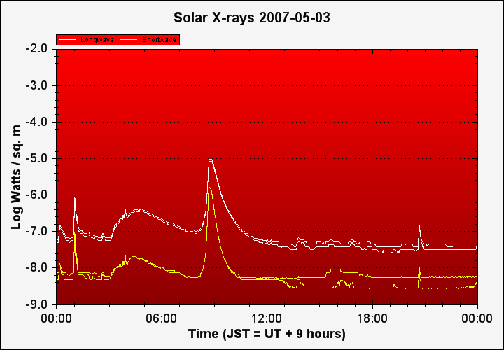Now let’s look at a trace on a day with a small solar flare. Before turning to the SSRT output, figure 2.4 shows the plot of solar X-rays as detected by NASA’s GOES satellite on May 3rd 2007.

Fig 2.4.

Plot of solar X-rays received by NASA’s GOES weather satellites on the day of a small solar flare that took place around 08:30 JST. The GOES satellites measure both long-wave X-rays (white) and short-wave X-rays (yellow).

The flare occurred at around 08:30 JST (Japan Standard Time) on May 3rd, 2007. The total X-ray flux from the sun increases about 100 fold when the X-rays emitted by the flare reached Earth. Solar flares are categorized according to their strength, as measured in Log Watts / Sq. m (the scale used in figure 2.4).

This flare was a C class flare, with a power just below -5.0, and was pretty much at the limit of detectability for the Solar Storm Radio Telescope. The strongest flares are X-class, and have a power of -4 or greater on this scale. The series is in table 2.1.

|  |  |  |  |
| --- | --- | --- | --- |
| Solar Flare | X-ray flux  (Log Watts / Sq. m) | Effect on the Earth | Detection by the Solar Storm Radio Telescope (SSRT) |
| X | -4 | Potentially serious impact on satellites and communications. | Strong signal that easily stands out against the background trace. May saturate the receiver. |
| M | -5 | Some impact on radio communications | Easily detectable, but set against natural background of ionosphere fluctuations |
| C | -6 | Minor | Detectable |
| B | -7 | None | Limit of detection |
| A | -8 | None | Not detectable |

Table 2.1. Classification of solar flares

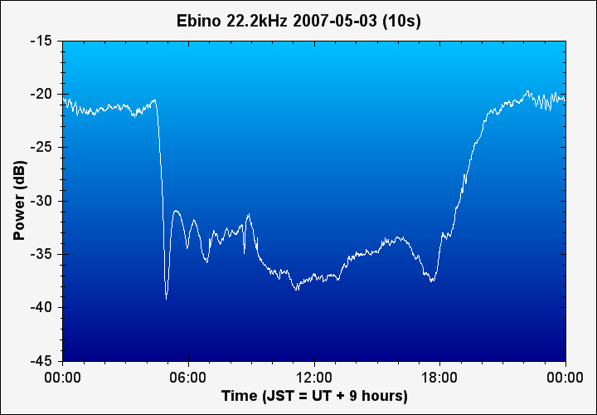Now let’s look at the output from the SSRT at the time of the flare, in figure 2.5 below. Has the solar flare had an impact on the propagation of the radio signal by the ionosphere?

Fig 2.5.

Output of the SSRT on the day of a small solar flare at 08:30 JST. There is a discernable increase in the signal strength at that time, but it is no stronger than the natural background of daytime ionosphere fluctuations

There is a discernable increase in the signal strength at 08:30 JST, but it is no stronger than the natural background of daytime ionosphere fluctuations. The magnitude of the change looks swamped by the natural background fluctuations. We need to zoom in to the time of the flare to confirm that we have really captured it.

The graph of Solar X-rays in figure 2.6 allows us to fix the time of the flare more clearly. We should be expecting a sudden disturbance in the ionosphere to take place sometime between 08:30 and 08:45 as the X-ray flux increases 100x during that period. Figure 2.7 is a graph of the received power of the VLF signal between 08:00 and 09:00 that day. You can see an abrupt increase in signal power at 08:40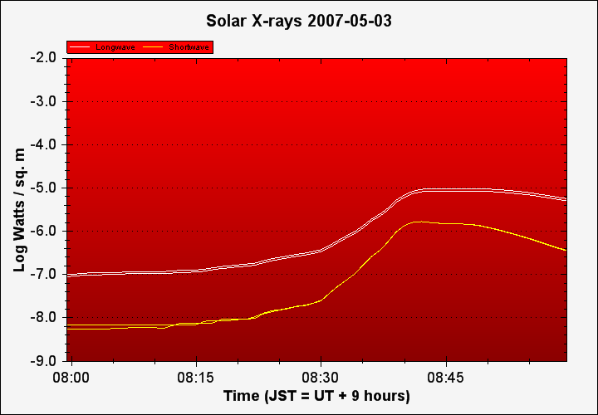, which combined with the timing of the X-ray flux increase, is the evidence of a sudden ionosphere disturbance.

Fig 2.6.

Solar X-rays increased 100 fold, starting to ramp up at about 08:25 JST and reaching a maximum at around 08:40 JST.

This flare was relatively weak, and so it has the benefit of forcing us to examine its effects more carefully. The examples in chapter 10 show the striking impact of much stronger M-class flares on the VLF signal.

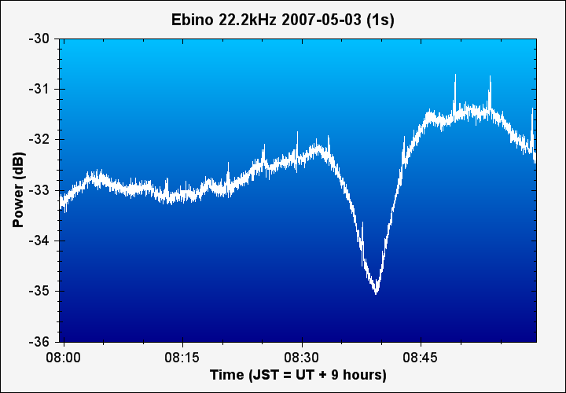

Fig 2.7.

Output from the SSRT. There is an abrupt increase in the signal just before 08:40 JST, as solar X-rays were reaching their maximum. This flare was at the limit of detection for the SSRT in question. See also pages 53 and 54 for more typical traces caused by stronger flares.

## The SSRT can be built simply, using a minimum of electronic components, and utilizing your home PC

Now that we’ve briefly understood what the SSRT is trying to do, let’s take a look at what it looks like and how it works. Figure 2.8 is a block diagram that shows the whole system.

Fig 2.8. Block diagram of the SSRT. It shows the key components of the antenna, the amplifier, the PC soundcard, and the software for logging and charting



The overall scheme starts with an antenna that captures the VLF (Very Low Frequency) signal. The antenna shown in the figure is outdoors, but an indoor antenna can equally well be used – Chapter 6 has details. The received signal at the antenna is very weak. It is immediately amplified with a simple electronic circuit based on a common and inexpensive integrated circuit. The amplifier is powered by a 12V wall-wart transformer or a large battery. The SSRT is a digital system, and the amplified signal is brought along a connection cable and digitized by a PC soundcard. Custom software logs the digitized signal and graphs it against time to produce charts like the ones shown above.

To help guide you through the construction of the radio telescope, here are some images of the finished antenna and amplifier.

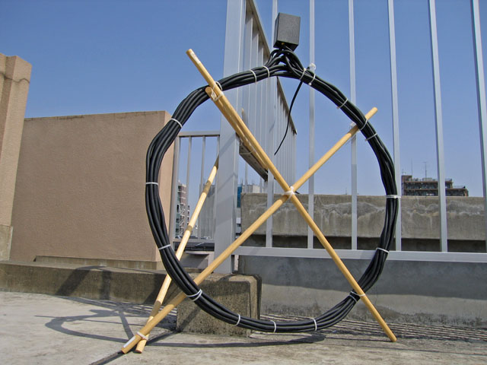

Fig 2.9. The antenna of my own SSRT. This is formed out of unshielded 20m of 20 core wire, wound into a loop roughly 80 cm in diameter. The wire bundle is held together by cable ties, and is almost fully self-supporting, just needing cross-bracing from two wooden dowels. The black box on top is the amplifier.

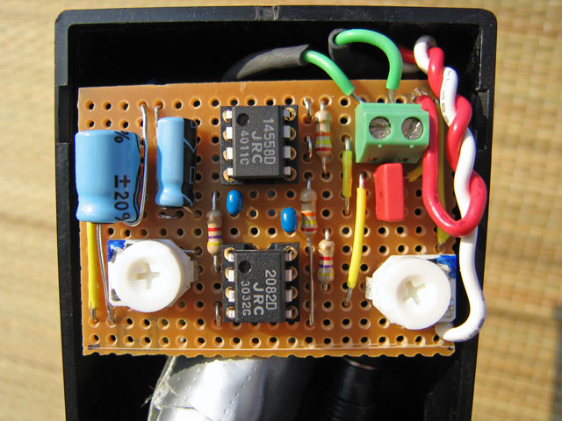3. What you’ll need to build the SSRT

Fig 2.10. The amplifier of my SSRT. This is built using basic electronic components and two operational amplifiers (op-amps). I constructed my amplifier on strip-board, but proto-board is just as suitable

## You’ll need some skills in electronics and computers, but the radio telescope can be your first project.

Building a radio telescope is much easier than you might think. The SSRT is simple enough to be a first project in electronics.

Off-the-shelf free software is available, but you can adapt it or develop your own.

Please refer to appendix A3 for a complete parts list.

## You’ll need some wire and basic electronic components

The antenna is formed out of a loop of about 150 turns of insulated wire. Total length of wire is about 200m. (We’ll go into the more detailed design later.) There are three main choices for the wire as shown in table 3.1 below.

|  |  |  |
| --- | --- | --- |
| Enameled copper wire | Enamelled_Copper_Wire | Enameled copper wire is the least expensive option. The disadvantage is that it is not self supporting, so that you will need some sort of former (for example an X-brace) to wind the wire around. AWG 26 is a good choice. |
| Hook-up wire | Stranded_wire | Insulated, stranded hook-up wire is another alternative. Using a thicker wire, such as AWG 20, will reduce the electrical resistance of the antenna and improve its performance. Like enameled wire, you’ll need to use a former to wind it around. |
| Multi-core wire (unshielded) | unshielded-wire | Multi-core, unshielded, wire is my first choice. It’s a little more complex, as you need to join all the individual strands in series. The big advantage is that a loop of about 10 turns of multi-core when glued or tied together is quite self supporting and does not need a former. It’s also often less expensive, length for length of total wire, than hook-up wire. Number of cores is not critical. I suggest you look for a cable with 10 – 20 cores of AWG 20 – 22 wire inside. It must be unshielded. |

Table 3.1 Choosing wire for the antenna

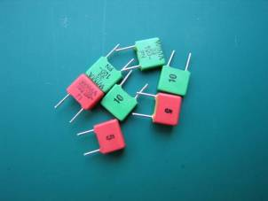For tuning the antenna you’ll need to use a selection of small capacitors. Polypropylene capacitors perform better than ceramic capacitors and will give your antenna a sharper resonance (otherwise known as a high ‘Q’). Tuning the antenna is a trial and error affair, so you’ll need to have a selection of polypropylene capacitors available to choose from. I’ve listed the recommended polypropylene capacitors in the complete parts listing in table 5.1 and appendix A3.



The pre-amplifier is built around a two-stage JFET op-amp. You’ll need two op-amp integrated circuits (IC’s), and some other basic electronic components. These are available mail-order from suppliers such as Mouser or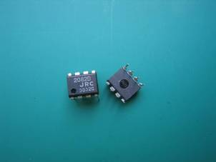 Digi-Key. Both Mouser and Digi-Key ship internationally and are happy to serve retail customers. The parts listings includes Digi-Key part numbers

The board can be constructed on either perf-board or strip-board. I prefer strip-board myself because it requires fewer wire links and can be neater, but you can make a smaller layout on perf-board and it’s the more common choice. This is a soldering task, so you’ll also need a soldering iron and solder (and eye-protection) if you don’t already have them. Unless you are experienced in electronics it’s a good idea to build and test the circuit on breadboard first, before committing the components to a permanently soldered board. Table 3.2 summarizes the construction options. All of these boards can be found in cheaply in local electronic stores and on eBay.

Fig 3.2. Operational amplifier IC’s for the SSRT amplifier

|  |  |  |
| --- | --- | --- |
| Breadboard | Perf-board | Strip-board |
| breadboard | 180px-CopperCladPerfboard_1 | stripboard |
| Temporary construction for circuit testing | Permanent soldered layout | An alternative for the permanent layout |

Table 3.2 Boards for circuit construction

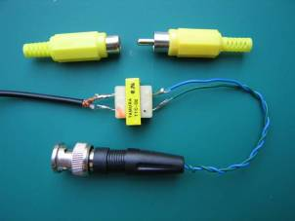The transmission line to bring the signal from the antenna/amplifier to the PC soundcard is ordinary 75 ohm coaxial cable (coax). Typically 10 - 20 m is enough. At both ends of the transmission line you’ll need a 600 ohm audio isolation transformer to help limit interference in the SSRT. This works because any induced interference should be equal in both wires of the coax line, and so should not be transmitted through the transformers. Connections can be BNC, or more cheaply, and they work just as well, phono plugs. Figure 3.3 shows a coax cable wired to an audio isolation transformer, and both BNC and phono plug connectors. You’ll need an audio jack to plug into the soundcard

Fig 3.3. Connection between the antenna/amplifier and the PC soundcard is made with ordinary coax cable. Audio isolation transformers on either end limit electrical interference

## You’ll need a PC with a soundcard

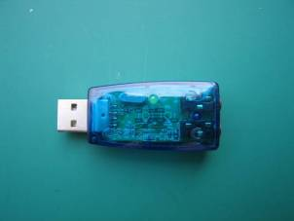The soundcard used to receive the signal will need to be full time dedicated to the SSRT. This means that unless you have a second PC, you’ll probably want to obtain an additional soundcard. There are three soundcard options: the onboard soundcard built into the mother board of most machines, an additional internal soundcard (fitted to one of the expansion slots inside the computer case), or an additional USB soundcard (an external device connected through the USB port).

Look out for a few features in choosing a soundcard. The most important is maximum sampling rate. You’ll need a sampling rate of at least double the frequency of the VLF station that you intend to monitor. Nearly all modern soundcards support a sampling rate of 48 kHz, and this will be fine for most purposes. Better sound cards support a sampling rate of 96 kHz. It’s also somewhat beneficial to use a soundcard that has separate line-in (color blue) and microphone (color pink) inputs. The line-in input is more suitable for connecting the SSRT since it bypasses the soundcard’s own internal high gain amplifier.

Fig 3.4. A USB soundcard can be bought very cheaply on eBay and is a handy way to connect the SSRT to your PC

You can make use of the external USB sound card option if you don't want to connect anything directly to your PC. Even the really low cost units work satisfactorily.

Any reasonably modern PC will be up to the task of processing the radio telescope inputs with minimal background effort. You will need quite a lot of hard disk capacity: the SSRT generates about 5 – 6 megabytes of data each day. In terms of operating system, the software that I describe in this book and my own radio telescope software that’s distributed free with this book work on Microsoft Windows XP or above.

## You’ll need an oscilloscope and a function generator to tune the antenna and test the circuit

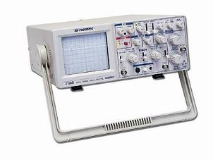Don’t be intimidated by the idea of using an oscilloscope. If you haven’t used one before, this is a great chance to learn. The testing and tuning you’ll do in the process of constructing your SSRT is very straightforward and just makes use of the most elementary oscilloscope functions.

Getting hold of an oscilloscope need not be expensive or difficult. There are two basic choices. A standalone unit with its own display, or a PC oscilloscope that connects through USB or Ethernet and uses the PC screen as a display.

Fig 3.5. A standalone oscilloscope.

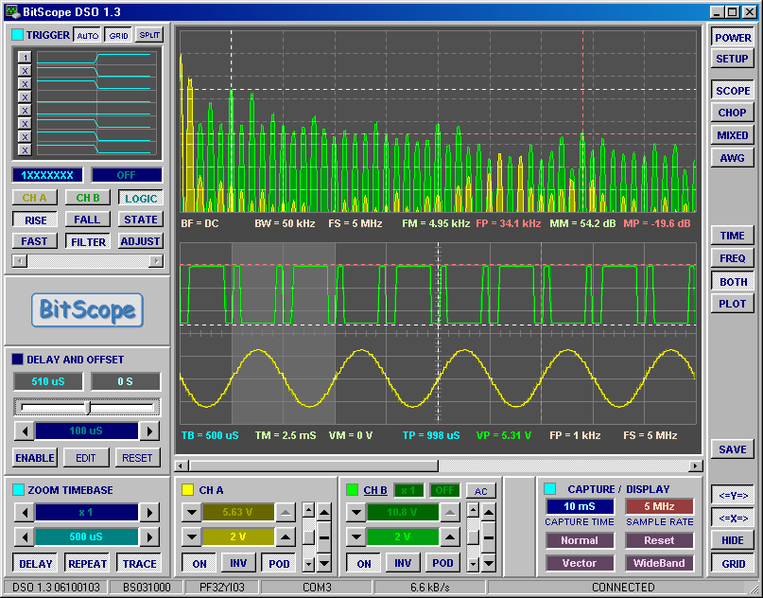A standalone oscilloscope looks daunting with so many knobs and switches. It can also be quite expensive to buy new. There are two basic types: older analog units and modern digital ones. Either is fine for testing the SSRT. Expect to pay at least $300 for a modest secondhand unit in reasonable condition. Figure 3.5 is typical.

A PC oscilloscope is a modern digital oscilloscope that saves space and cost by using the PC for its display and controls. They are typically much better value than stand-alone units. There are a number of models on sale through the internet, and prices range from $250 to over $1,000. Don’t make the mistake of assuming that more money buys a better unit – with advancing digital technology some of the newest and least expensive are also among the best. I use and recommend the Bitscope (<http://www.bitscope.com/>) with which I have had very good results (figures 3.6 and 3.7).

Fig 3.6. PC oscilloscope interface.   
Credit: BitScope

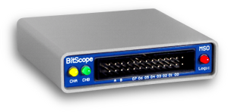You are also going to need a function generator. This is a simple circuit that generates a sine wave signal at a variable frequency selected by the user. We’re going to use this to test the resonant frequency of the antenna, by playing sine waves into wire loosely coupled to the antenna, and seeing at which frequency the received signal is strongest.

Fig 3.7. The BitScope Pocket Analyzer.

Credit: BitScope

Getting hold of a function generator is also not expensive or difficult. You basically have two options: buy a dedicated function generator (about $200 and up on eBay) or make your own. Building your own on a piece of breadboard is simple and easy (essentially one IC and some passive components) and will cost you very little. There is a full circuit diagram in appendix A4.

## You’ll need software to read and chart the signal received by the SSRT

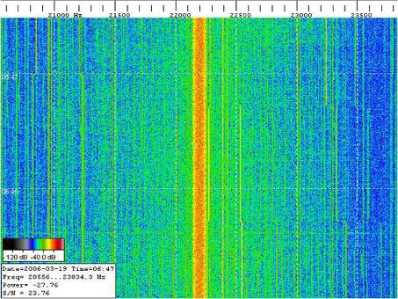The first piece of software that you will need is a tool to read the incoming signal from the sound card and log the signal strength to a text file. As well as the PC specific task of reading from the sound card, this step also requires filtering our VLF signal of interest from the other unwanted signals and noise that will inevitably be present. There are several software packages available. Fortunately one of the very best is also freeware: Spectrum Lab by DL4YHF. Spectrum Lab’s capabilities go way beyond the simple task of extracting and logging a signal. It can be used for all kinds of amateur radio applications, or audio analysis, even monitoring bat calls. In Chapter 8 I’ll explain how to configure Spectrum Lab.

Fig 3.8. Screenshot from Spectrum Lab

Spectrum Lab’s output will be a text file of dates and times, and the measured signal strength. Typically we’ll export data at 1 second intervals and a daily log file is around 5 megabytes in size.

# 4. Finding a suitable VLF radio transmitter

VLF radio transmitters are operating all around the world. Table 4.1 contains an up-to-date list of stations.

|  |  |  |  |
| --- | --- | --- | --- |
| Region | Station location | Freq (kHz) | Call sign |
| Russian Fed. | Russian navy, unknown | 11.91 | RSDN |
| Russian Fed. | Krasnodar, Russia | 12.65 | RSDN |
| Russian Fed. | Krasnodar, Russia | 14.88 | RSDN |
| India | South Vijayanarayanam | 16.30 | VTX1 |
| Norway | Aldra Island | 16.40 | JXN |
| India | Vijaya Narayanam | 17.00 | VTX |
| Sweden | Grimeton | 17.20 | SAQ |
| Russian Fed. | Matotchkinchar | 18.10 | RDL |
| India | Indian navy, unknown | 18.20 | VTX3 |
| France | Rosnay | 18.30 | HWU |
| Australia | Woodside, Victoria | 18.60 | NTS |
| Great Britain | Anthorn / Skelton | 19.60 | GBZ |
| Australia | Harold E. Holt | 19.80 | NWC |
| Russian Fed. | Russian navy, unknown | 20.20 | RDL |
| Italy | Isola di Tavolara | 20.27 | ICV |
| Russian Fed. | Russian navy, unknown | 20.50 | RJH6x |
| France | Sainte-Assise | 20.90 | FTA |
| Russian Fed. | Krasnodar,Tashkent | 21.10 | RDL |
| USA | Pearl Harbour, Lualuahei | 21.40 | NPM |
| France | Rosnay | 21.75 | HWU |
| Great Britain | Anthorn | 22.10 | GQD |
| Japan | Ebino, Kyushu | 22.20 | NDT |
| France | Rosnay | 22.60 | HWU |
| Germany | German Navy, Ramsloh | 23.40\* | DHO38 |
| USA | Cutler, ME | 24.00\* | NAA |
| USA | Jim Creek,WA | 24.80\* | NLK |
| Russian Fed. | Russian navy, unknown | 25.00\* | RJH |
| USA | La Moure, ND | 25.20\* | NML |

\* These transmitters operate at frequencies that are too high to digitize with typical 48 kHz PC soundcards. A 96 kHz soundcard would be required to monitor any of these.

In addition to the stations listed here there are some less well identified VLF transmitters throughout Russia and in China. These are lower power and transmit irregularly, or from multiple sites, and are less suitable for monitoring.

Table 4.1 List of VLF transmitters

You’ll need to select which of these transmitters you want to monitor in advance because the SSRT antenna must be specially tuned for that frequency.

Choose a transmitter that is:

* As powerful as possible – this makes distinguishing the signal from background noise easier and reduces the impact of local interference
* Ideally at a distance of between 500 – 5,000 km (depending on the transmitter power). If you are too close to the transmitter the received signal may not show as much sensitivity to smaller changes in the ionosphere. If you are too far away and the signal may be too weak to detect.

An easy way to calculate the distance from your SSRT site to a candidate VLF transmitter, and confirm in which direction it lays is to use the freeware Google Earth software’s ruler tool.

Since VLF signals are more strongly propagated by the ionosphere at night time, I recommend that when you are searching for a new station, you do so from about an hour after sunset until about an hour before sunrise. Local radio interference due to machinery, computers and air-conditioners may also be lower in the evenings, which is another advantage of searching for signals after dark.

Most VLF transmitters are shut down for maintenance about once a month, usually during the daytime. If you are searching for a station and it doesn’t seem to be there, don’t give up too soon - try again a day or two later. Likewise if your signal suddenly disappears from the SSRT output chart, don’t automatically assume that your equipment has developed a fault, it might just be a maintenance shutdown.

You may want to take a look at the Solar Storm Radio Telescope online network (details in Chapter 12) where you can see a map showing the locations of active VLF transmitter stations.

# 5. Building the on-board electronics

The SSRT is a digital system. The key purpose of the on-board electronics is to amplify the signal received in the loop antenna and transfer it to a PC soundcard to be digitized. The circuit schematic is shown in figure 5.1 below.

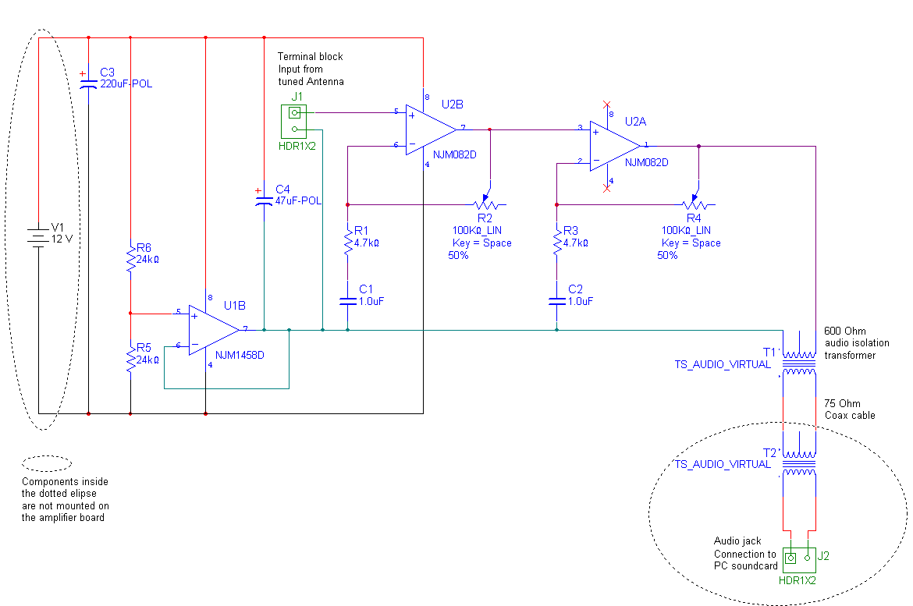

Fig 5.1. Schematic of the on-board electronics

The core of the circuit is U2, a dual 082-type JFET operational amplifier. The input to the first stage of the amplifier is connected across the ends of the loop antenna with a terminal block. The first stage of the amplifier provides a variable gain of up to ~20x according to the position of the trimmer R2. Only the AC component of the signal will be amplified. C1 ensures that there is no gain in the DC component. The second stage of the amplifier provides an additional gain of up to ~20x.

The amplifier is less susceptible to local interference and compression if the second stage is turned to the minimum gain of 1, and the first stage only is used for amplification.

Positive and negative voltage power for U2 is provided by V1: either a 12V battery or a traditional wire-wound mains transformer. A switched mode power supply (i.e. the more modern type of small-sized mains transformer distributed as an accessory for most consumer electronics) cannot be used as this type of transformer introduces significant interference in the VLF band. Capacitor C3 stabilizes the power supply input.

A zero point mid-way between the positive and negative voltage power is provided by U1, a traditional 741-type op-amp. R5 and R6 form a 50:50 voltage divider between the two power rails. This voltage point is connected to the input of U1 which is wired in a voltage follower configuration to provide a stable current source at the mid-point voltage. Capacitor C4 stabilizes the mid-point voltage.

The output from the amplifier board is brought to the PC soundcard using a 75 Ohm coax cable. The cable is isolated against locally induced interference by a pair of audio isolation transformers at each end. This works because any local interference induced in the coax should be equal in both lines of the wire and will not be transmitted through the transformers. These transformers are essential, as local interference caused by TV’s, PC’s, air conditioners, fridges, etc. are the main enemy of our task in monitoring the delicate VLF signal.

Note that antenna tuning capacitors which should also be placed across the ends of the antenna are not shown in figure 5.1.

I suggest that you first build the amplifier on breadboard and test it with the signal generator and oscilloscope. To test the amplifier feed a weak sine-wave signal at around 15 – 20 kHz into the terminal bock J1 with the signal generator, and monitor the output at T1 with the oscilloscope whilst adjusting the gain with the trimmers R2 and R3. You can use a voltage divider to reduce the voltage of the signal generator output if necessary.

Fig 5.2. A finished amplifer on strip-board. The audio transformer is mounted on the rear of the board

After testing the circuit on a breadboard, construct it permanently on perf-board or strip-board. Figure 2.10 is a picture of a finished amplifier that you might want to refer to for guidance. If you are constructing on strip-board, then I recommend the CAD layout software VeeCAD to help you design your layout.

Table 5.1 contains the full parts list. The list includes the polypropylene capacitors that are not shown in the schematic figure 5.1, but which are used to tune the antenna. Part numbers are listed for Mouser, but Digikey or Jameco are likely to have similar parts available. This is the minimum list of parts. I strongly recommend you buy extra items, especially of the IC’s, in case anything is broken during assembly or for maintenance later on.

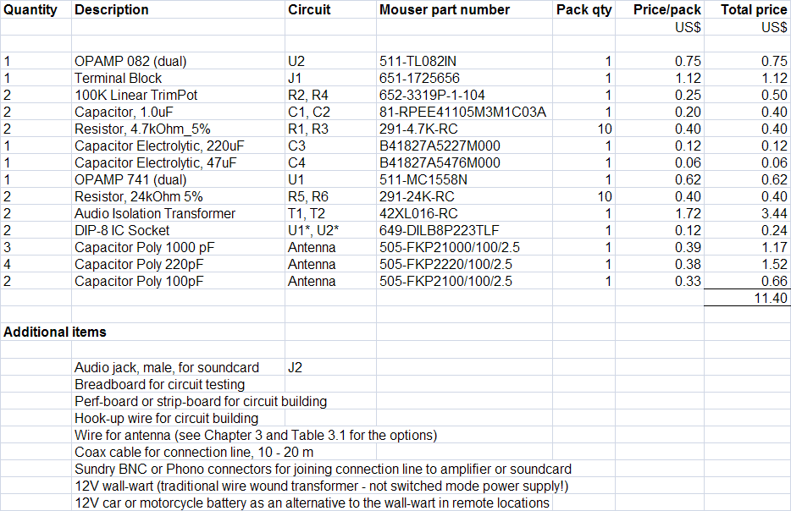

Table 5.1. Complete parts list for the on-board electronics

The Unihedron CapSelector is a switchable variable capacitor that can be used for convenient antenna tuning.

<http://www.unihedron.com/projects/sidcaps/>

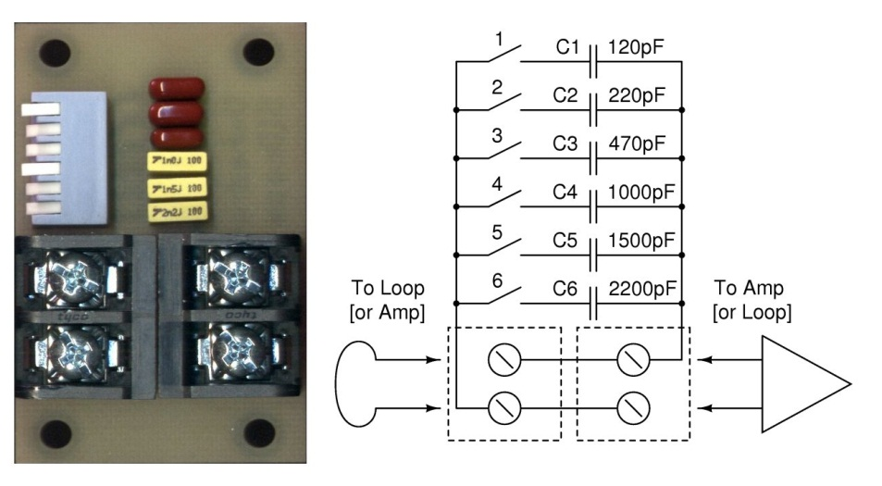

# 6. Building the antenna

## SID_antennaDesign the antenna to match the VLF station that you want to receive

The antenna design is a loop of about 150 turns of insulated wire, diameter about 70cm. Total length of wire is about 200m. The number of turns of wire, the diameter of the loop, and the value of a small polypropylene tuning capacitor must be determined so that the antenna has a natural resonance at the frequency of the VLF transmission that you intend to monitor. The same design is used indoors and outdoors, but you may optimized the design for convenience indoors by using enameled wire (thinner) and a smaller diameter loop, compensating with the number of turns of wire, as shown below.

Fig 6.1. A finished antenna installed outside. The amplifier is mounted in a weatherproof box on top

## You can get a rough idea of the antenna dimensions using some calculations

The resonant frequency of the antenna is related to the inductance of the loop of wire and the total capacitance of the wire plus the tuning capacitor as follows:

**F = 1 / (2 \* pi \* ((L \* C) ^ (1/2)))**  [Eq. 6.1]

where:

F = resonant frequency in Hz

L = inductance of the loop in Henrys

C = capacitance of the loop and tuning capacitor in Farads

The inductance of the loop is related to the thickness of the wire used to construct it, its diameter, and the total number of turns as follows

**L = Mu \* r \* N^2 \* (ln (8\*r/R) – 1.75)**  [Eq. 6.2]

where:

Mu = 4 \* pi \* 10^-7

r = radius of the coil in meters

R = radius of wire conductor

ln () = natural logarithm

N = number of turns

Table 6.1 is worked example of how to do the calculation

|  |  |  |  |  |
| --- | --- | --- | --- | --- |
| Calculation of antenna inductance | |  |  |  |
| Radius of loop | 0.30 | meters |  |  |
| Radius of wire | 2.60E-04 | meters |  | AWG 24 |
| Number of turns | 120 |  |  |  |
| Length of wire | 226 | meters |  |  |
| Inductance | 0.040 | Henrys |  |  |
|  |  |  |  |  |
| Calculation of antenna resonant frequency | | |  |  |
| Intrinsic loop capacitance | 1.00E-09 | Farads |  | Assume this value initially |
| Tuning capacitor | 5.00E-10 | Farads |  | 500pF tuning capacitor |
| Resonant frequency | 20530 | Hz |  |  |
|  |  |  |  |  |

Table 6.1 Calculation of approximate antenna resonance. Yellow boxes are inputs.

We’ll assume your loop is going to be about 30 cm radius and that you’ll be using AWG 24 wire. If you wind 120 turns the inductance of the antenna will be 40 mH. We’ll assume the loop has an intrinsic capacitance of 1000 pF, and go for a 500 pF tuning capacitor. The result is that the antenna will resonate at about 20.5 kHz. If we want to achieve a different resonant frequency, we can play around with the number of turns of wire or the value of the tuning capacitor until we have roughly the right design.

There is an open source spreadsheet distributed with this book that has these calculations prepared. Alternatively, VLF expert Paul Nicholson has written freely available C software that you can use <http://abelian.org/acmi/>

It’s important to realize that these are just rough calculations to constrain the design a little. Once the antenna has been constructed it will have to be tuned by trial and error using the signal generator and oscilloscope

## Build the antenna according to the rough design dimensions

You can use enameled copper wire, hook-up wire, or multi-core wire to form the loop. Table 3.1 illustrates these three wire options and explains their advantages and disadvantages. You may need to use a former of some sort to wind the wire around. That can be a simple X-cross brace, in which case you would end up with a square coil rather than a round coil, but this is just as suitable. (Equation 6.1 assumes a round coil. A square coil’s inductance will be a little smaller since for the same length of wire and number of turns it will have a smaller cross sectional area.)

## Use the signal generator and oscilloscope to determine the antenna’s natural resonance

Once you’ve built the loop, and without connecting any tuning capacitor at this stage, you’ll need to determine its natural resonant frequency. Follow this procedure:

1. Connect the oscilloscope probes directly across the open loop terminals (do not use any coax in between)
2. Make a single loop of wire about the same diameter as the antenna and position it about 10cm distant and parallel to the antenna. Connect the signal generator across the ends of the single loop of wire
3. Set the signal generator to produce a sine wave at about 5kHz
4. Measure the voltage induced in the antenna at that frequency using the oscilloscope. Record it.  
     
   (Oscilloscopes that have a frequency mode, showing the voltage of the signal across frequency buckets, make this step easy)
5. Increase the signal generator frequency by say 5kHz, to 10kHZ and repeat the measurement
6. Continue testing the antenna in this way right up to about 30kHz
7. Identify the natural resonance of the antenna by the peak voltage

Table 6.2 contains the data I obtained when tuning my own antenna. You can see that my antenna had a natural resonance somewhere around 15 kHz as it was configured at that time.

|  |  |
| --- | --- |
| Frequency (kHz) | Induced voltage (V) |
| 5 | 1.34 |
| 10 | 4.23 |
| 15 | 5.22 |
| 20 | 2.92 |
| 25 | 2.02 |

Table 6.2 Experiment to determine the natural resonance of a VLF antenna

## Tune the antenna to the frequency of the VLF station that you intend to monitor

You can tune the antenna as follows:

* To decrease the resonant frequency, increase the value of the polypropylene tuning capacitors connected across the ends of the loop  
  + Polypropylene capacitors are used in preference to ceramic capacitors because they have a lower intrinsic inductance and so will give the antenna a sharper resonance (higher ‘Q’)
  + One way to connect the tuning capacitors at the tuning stage is to use crocodile clips and breadboard. Place the capacitors in parallel on the breadboard to build up the value you need, and then link them to the antenna ends with test wires terminated in crocodile clips
  + The selection of polypropylene tuning capacitors in table 5.1 (the parts list) should be enough to tune a typical VLF antenna
* To increase the resonant frequency of the antenna, decrease the capacitance or, for larger adjustments, reduce the number of turns of wire forming the loop

Repeat the test with the signal generator to find the resonant frequency after each adjustment, until you have homed in within a few hundred Hz of the desired frequency.

## Finalize the construction of the antenna

Once the antenna has been tuned you can connect it to the amplifier. The polypropylene tuning capacitors should be soldered in place, either directly across the ends of the loop, or alternatively on the amplifier board, just after the terminal block J1.

One last check to make: the antenna itself will need to be mechanically rigid. This is essential to stable signal monitoring, especially if the antenna is to be placed outside. A bundle of multi-core wire glued or tied in place across a couple of wooden dowels works very nicely without the need to construct an elaborate former. Wrap it in Duck Tape to stop the Sun’s UV rays from attacking the cables.

# 7. Installing the radio telescope

## Point the antenna in the direction of the transmitter that you intend to monitor

The loop antenna has directional sensitivity. It receives most strongly in the plane of the loop, and there is reception minimum in the perpendicular direction.

## Choose a site that minimizes local interference

Interference is minimized by getting away from the household electrical system, especially mains electric wiring. If you have the opportunity, then you may want to install the antenna outside. In this case you must mount the amplifier in a waterproof case since it needs to be attached directly to the antenna. Of course the antenna mounting also needs to be stable against the wind and rain if mounted outside.

In general it’s also best to avoid being close to metal structures such as railings. (Figures 2.9 and 6.1 break that rule, but this site was found through live testing to have the best reception in the local area.)

## Mount the antenna with a temporary fixing at first

After you have installed the PC software and are able to detect the VLF signal from the station that you are monitoring, you may want to fine tune the position and orientation of the antenna to optimize the quality of reception

## Connect the SSRT to the PC soundcard, but leave it switched off for now.

We’ll power on after the necessary software is installed, as explained in the next chapter.

**Precaution**



Disconnect the antenna during a thunderstorm, especially if it is outdoors. You must unplug both the power supply cable and the signal cable from the amplifier to the PC soundcard. This is to avoid the conduction of any electrical surges inside or around your home.

(It is not a problem to leave the amplifier circuit still attached to the antenna. Although an op-amp IC may blow in a strong thunderstorm, it can be easily replaced if you have used IC sockets on the board and have some spare op-amps to hand.)

# Blank page

# 8. Installing the PC software and finding the signal

## Signal processing is done in a two-step process

The first step is to digitize the signal received at the sound card, perform a fast Fourier transform on it, measure the power of the VLF transmission of interest, and output time stamped readings to a text file log. The whole of the first step is accomplished with Spectrum Lab, a freeware audio analysis package by DL4YHF.

The second step is to produce charts of the power against time by reading the log files and graphing them. The second step is accomplished with SSRT Robot, an open source package that I am distributing with this book.

## Download Spectrum Laboratory and configure it to capture the input signal from the SSRT

It is essential to use the latest version of Spectrum Lab (V2.76b2 or later), from <http://www.qsl.net/dl4yhf/spectra1.html#download>

Spectrum Lab is very full featured audio analysis software, but we’ll just need to take advantage of some of its basic capabilities. Configure Spectrum Lab as follows.

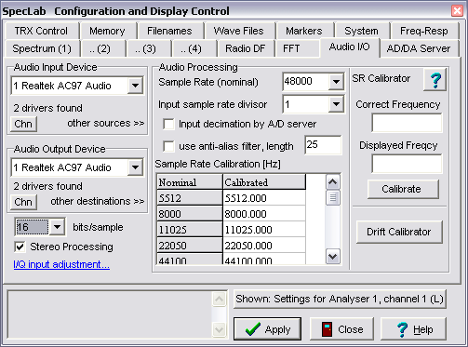

Figure 8.1 shows the Options/Audio Settings dialog.

Ensure that:

* Audio Input Device is set to your chosen soundcard if you have more than one
* bits/sample is set to 16
* Sample Rate is set to 48,000 (or higher if your soundcard supports it)
* Stereo Processing is enabled

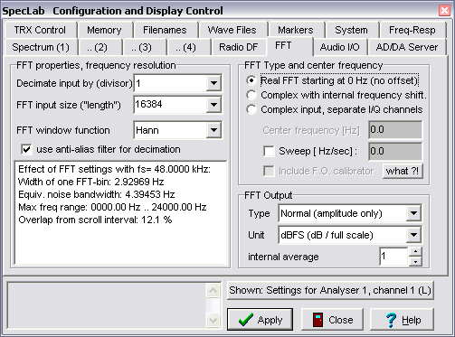Figures 8.2 shows the options / FFT settings dialog. Ensure that FFT input size (“length”) is set between 16384 and 65536 (trades off faster display update vs. smoother noise reduction, but very little impact for this application)

Fig 8.1. Spectrum Lab’s Options/Audio Settings dialog

Fig 8.2. Spectrum Lab’s Options/FFT Settings dialog

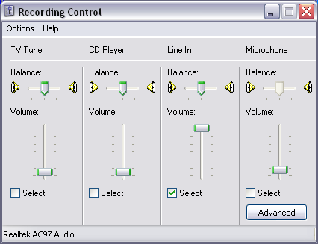

Figure 8.3 shows the options / Volume control for “Record” (audio in) dialog. (This dialog will likely look different on your system). Ensure that the appropriate input channel is selected (it will be either Line In or Microphone, depending on how you are connecting the SSRT).

Set the volume. For line in, set the volume to maximum. For microphone, set it near minimum, say at level 2 or level 3. (The microphone input has a high gain amplifier that can be counterproductive. We want the necessary amplification done by the on-board amplifier at the antenna *before* transmission of the signal along the coax.)

A word of caution for Skype users: Skype can reconfigure the recording control settings that are used by Spectrum Lab. To prevent this, under Skype / Options / Sound Devices, uncheck the box “Let Skype adjust my sound device settings”.

Fig 8.3. Spectrum Lab’s Options/ Volume control for “Record” (audio in) dialog

## Connect the SSRT to the PC and test for a received signal

At this stage the antenna should be mounted so that the plane of the antenna loop points in the direction of the VLF transmitter that you intend to monitor. The amplifier is connected to the antenna and supplied with 12V power. A line from the amplifier is connected to the PC soundcard. The gain of the amplifier is set near minimum initially.

Switch on capture of the input signal with the Start/Stop /Sound Thread menu command. Then open up the View/Windows /Input Monitor Window shown in Figure 8.4. Gradually increase the gain in the first stage whilst looking for the signal on the Spectrum Lab waterfall display, as explained in the next chapter.

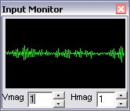Ensure that:

* There is a visible signal in the input monitor. If the green line is flat, then increase the gain of the SSRT amplifier until the signal becomes visible at approximately the level shown in Figure 8.4. Ideally you should only need to use the first stage of the dual amplifier on the SSRT’s on-board electronics to provide the necessary gain. So, keep the gain in the second stage turned right down unless the signal is very weak.

Fig 8.4. Spectrum Lab’s View/Windows /Input Monitor

* The signal trace is green, not red. If the signal trace turns red then the signal is overwhelming the analog to digital converter (ADC) in the soundcard. In that case reduce the gain on the SSRT amplifier

Getting to this stage is a key achievement. You have a working antenna and amplifier and the PC is receiving the signal and interpreting it. Now it’s time to search for the VLF signal from the transmitter that you are intending to monitor and start logging its strength.

## Interpret the signal SL5being received from the SSRT through the waterfall diagram

Fig 8.5.

Spectrum Lab’s waterfall display

Figure 8.5 is a screenshot of Spectrum Lab successfully capturing a signal from the SSRT. Check the following features:

* At the top of the screen the graph with the black background and yellow trace shows the level of the input signal at each frequency bucket. This is the result of the fast Fourier transform (FFT) that lies at the heart of Spectrum Lab’s digital signal processing
* The frequency scale is in the white ribbon below the yellow/back graph. In Figure 8.5 it runs from 0 – 24 kHz. It can be adjusted in Spectrum Lab by clicking on the scale with the right mouse button and zooming in or out
* The colored area below the frequency scale is the waterfall diagram. This shows the development of the FFT over time, using a color coded scheme to indicate the level of the signal. The most recent FFT is at the top of the screen, the oldest at the bottom.

Being familiar with the waterfall diagram is essential to installing and troubleshooting the operation of the SSRT. Let’s look over some of its main features

* The signal is never black anywhere. This indicated that there is electromagnetic noise present at all frequencies. Noise comes from background radio interference, the amplifier in the SSRT, and the PC soundcard. Provided background noise is not to large, it will not cause much problem for the operation of the SSRT
* There are some narrow spikes at around 0 – 2,000 Hz that give a comb-like pattern on the waterfall diagram. This is caused by 50 or 60 Hz mains interference and associated harmonics. If the comb-like pattern overwhelms the waterfall diagram and reaches to the higher frequencies on the right hand side, then there is a mains interference problem with the set-up. In that case, try running the SSRT off batteries or with a different mains transformer, try rerouting the coax from the amplifier to the PC soundcard to get away from mains wiring, or try repositioning the antenna
* The background noise level becomes higher in a broad hump around the antenna’s resonant frequency. In figure 8.5, this hump runs from roughly 19.5 – 22.5 kHz, which is consistent with the resonant frequency of the antenna at about 21 kHz
* There are various individual noise spikes across the waterfall (e.g. at 15 kHz in figure 8.5). These are due to local electrical apparatus giving off stray signals. Provided that these signals are not close to VLF transmission signal, and that they are not too large then they should not cause any problems. This kind of electrical noise is commonly caused by TV’s, old style cathode ray tube (CRT) PC monitors, air conditioners, and kitchen appliances such as induction cookers
* There is a clear signal from a VLF transmitter at 22.2 kHz. This is the signal of interest. Figure 8.6 zooms in on the region immediately around 22.2 kHz. The signal itself is 200 Hz wide, which is a clear signature of a VLF transmitter. (Coded communications are contained within the 100 Hz side bands either side of the central frequency, but we will not be decoding these, just monitoring the overall power)

## SL6

Fig 8.6.

Spectrum Lab’s waterfall display. Zooming in on a VLF signal at 22.2 kHz

# 9. Logging the Radio Telescope Data

## Configure Spectrum Lab to log the VLF signal

Spectrum Lab has a very capable macro language that we will use to quantify and log the VLF signal being received. Now that we have identified a VLF signal we will make some important changes to the way Spectrum Lab calculates the waterfall and exports the data.

Time integration needs to be lengthened so that an appropriate amount of noise-smoothed data is exported for charting. This requires the selection of a larger FFT bin size (Options/ FFT Settings menu). In the example below FFT input size (“length”) is set to its maximum value of 524288. This gives an integration time of 10.9s with a 48 kHz sound card (i.e. 10.9 = 524288 / 48000). Internal average (#FFTs) has been set to 5 to give an overall integration time of roughly one minute. If a large FFT input size draws too much processor time (likely only on much older PC’s), then there is no problem to choose a smaller value and adjust other settings accordingly. Feel free to experiment.

Fig 9.1 Options/FFT Settings have been adjusted to provide appropriate data to charting

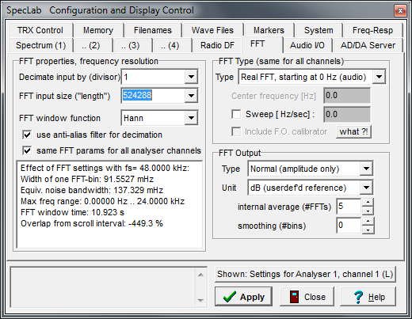

Now set the format of Export of Calculated Data (File/Text file export menu). Use the example below as a template, noting the format for the Time column and the inline calculation of spectrum power with the function

avrg(low\_freq, hi\_freq)

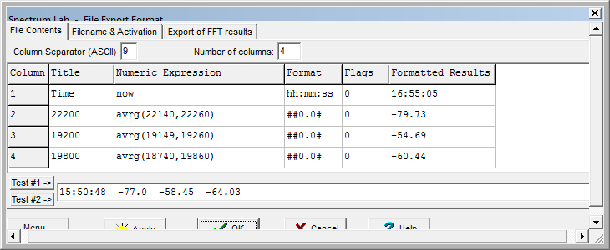

Fig 9.2.

File /Text File Export dialog

Note that although the full VLF signal is 200 Hz wide, in this case I am only sampling the central 120 Hz. This has a couple of advantages. Firstly the signal-to-noise ratio of the central 120 Hz is actually higher than the signal-to-noise ratio across the whole 200 Hz because the signal power declines either side of the central peak at 22.2 kHz. Secondly there is less chance of picking up an interference signal within the measured band if it is a little narrower (e.g. I have some problems with air conditioner interference in that region). On the other hand, don’t make the measured band too narrow or you’ll lose the natural smoothing that comes with averaging the received signal level across its bandwidth.

Spectrum Lab power units are in arbitrary units below the maximum level of the soundcard ADC. That’s why the value is negative

At least two columns are required, the first of which is the time stamp and the others are the measured level of the VLF signal. SSRT Robot 2 can display up to 6 separate signals (i.e. seven columns in total).

The Column Separator must be set to ASCII 9, which is the tab character.

The Waterfall Scroll Interval (Options / Spectrum Display Settings menu) should be set at around 60 seconds since this is also the interval at which the output data file is written to. Intervals shorter than 60 seconds can be used, but there is usually little practical benefit visible in the final charts (and the output data files will be larger).

Fig 9.3

Options / Spectrum Display Settings

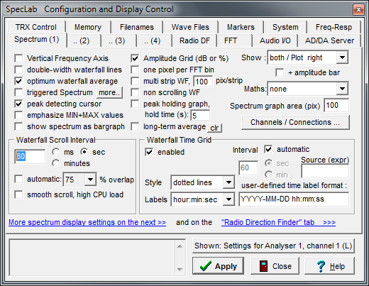

We want to produce a new log file each day, so we’ll need to use Spectrum Lab’s macro language to dynamically create and name

A new file every time Spectrum Lab is started and/or at midnight each day.

Figure 9.4 shows the File /Conditional Actions dialog. Insert in row 1, column IF the text

initializing | (val(str("hh",now)) == 0)

Insert in row 1, column THEN the text:

Fig 9.4.

File /Conditional Actions dialog

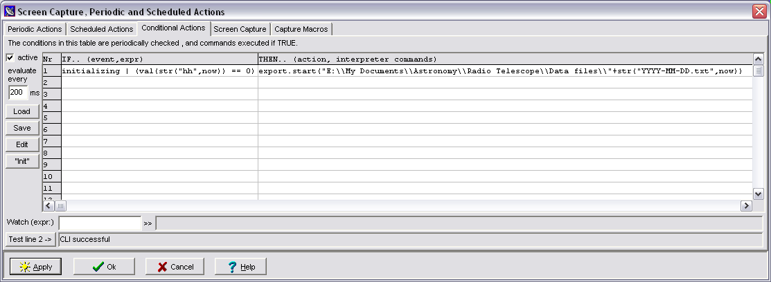export.start("E:\\My Documents\\Astronomy\\Radio Telescope\\Data files\\"+str("YYYY-MM-DD.txt",now))

Change the file path above to wherever on your hard drive you would like to create the log files. Note that the Spectrum Lab’s macro language is ‘C’ like and requires double ‘\\’ in strings. Take care to put the double ‘==’ in the conditional test too.

This macro will run either when Spectrum Lab starts or when midnight comes around, and will update the name of the export file according to the current date.

## Check that Spectrum Lab is producing the log files as expected

The table below shows a typical log file

Time 22200 19200 19800

00:00:51 -81.02 -47.3 -55.55

00:01:51 -81.64 -47.66 -55.87

00:02:51 -81.92 -47.71 -55.87

Please note the following file format requirements:

* A new data file should be produced each day, starting at 00:00 midnight local time
* The data files must all stored in a single directory
* The files are plain text ASCII
* The name of each file must be YYYY-MM-DD.txt (e.g. 2010-08-30.txt)
* The first line of each file is always ignored by SSRT Robot 2 (Spectrum Lab writes the column headings here)
* Each subsequent line of the file contains a reading from the radio telescope
* The first column is time of the reading in 24 hour clock format HH:MM:SS
* Subsequent columns contain the power levels of VLF frequencies being monitored
* Power levels can be positive or negative to arbitrary decimal places
* The decimal separator is the full stop character
* The separator character between columns is the TAB character (ASCII 9)
* SSRT Robot 2 can read up to six different signals (i.e. seven columns in total, including the time)
* A reading interval of about one minute is likely to give good results

## Configure SSRT Robot to chart the data recorded in the log files

SSRT Robot is the software that charts the data from the log files produced by Spectrum Lab. SSRT Robot runs on an hourly cycle to produce a graph of the current day’s signal and a more detailed graph of the signal for the last hour. The graphs produced each hour are saved to a folder on your hard drive with a date stamp. Like Spectrum Lab, once SSRT is started it continues to run indefinitely.

Unzip ”SSRTRobot2.zip” into a convenient folder and run “SSRT Robot 2.exe” directly. There is no installation necessary. A shortcut is provided and can be moved to your Start menu or another suitable location.

## SSRT Robot 2 setup

Note the important settings below

*Local disk settings*

Define the folder where the Spectrum Lab output data files are stored, and the root folder where SSRT Robot will store the charts it creates

*Signal settings*

Activate as many columns as you have exported data and want to chart. The *offset* value is optional and will be added to the data before plotting

*SSRT network settings*

*Activate SSRT online reporting*. Leave this **unchecked** for now, but see chapter 12 if you are interested in joining the network. For now the settings *SSRT station name*, etc. will be all left blank.

*NOAA GOES settings*

SSRT Robot has the ability to generate Solar X-ray charts to assist with the validation of possible SIDs, using NOAA GOES satellite data downloaded from the internet. Uncheck if your PC is not connected to the internet.

*Chart settings*

*Station title* is a heading chosen for the charts

*Signal floor*: a minimum applied to signal data before plotting to manage the effect dropouts on the charting

*UT offset*: (removed in latest version – now calculated automatically)

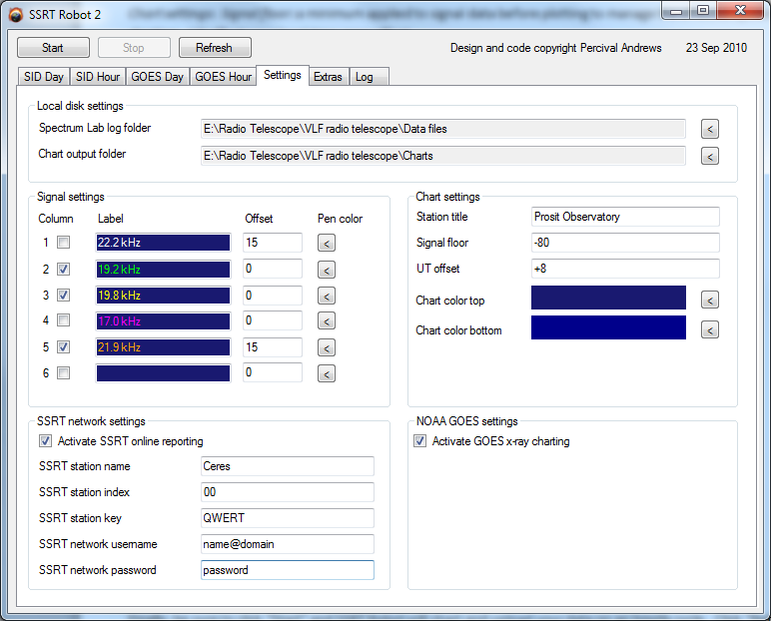

## SSRT Robot 2 operations

Click “Start” and SSRT Robot will chart (and upload) your data on an hourly cycle.

Click “Refresh” to see the latest data at any time.

Click “Process SID files” to re-process data files in a prior date range (SID Day graphs only).

Ignore “Upload Log File” for now unless you are participating on the online network.

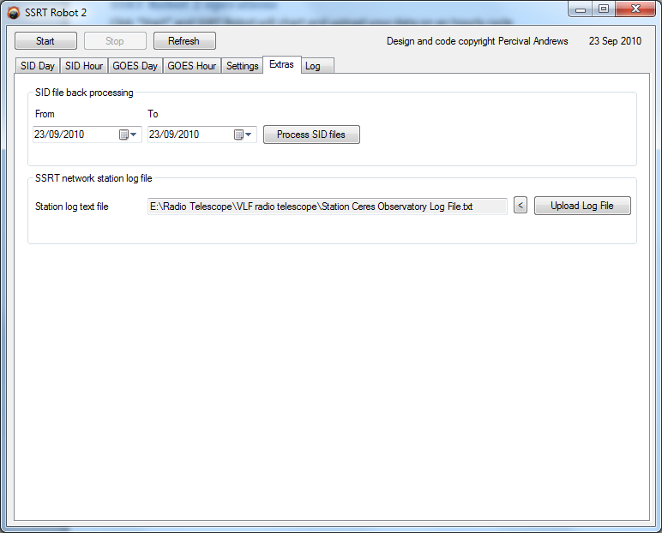

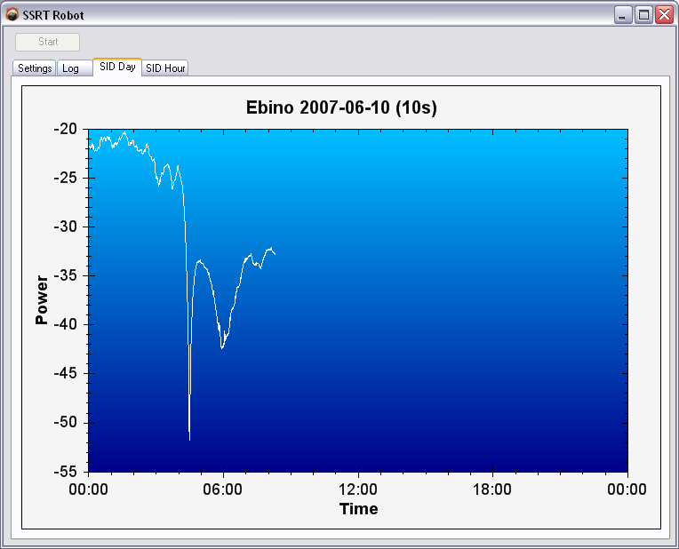The chart for the current day is shown on the left. Once started, SSRT Robot will run hourly to update this chart. SSRT Robot will save the graph as an image in PNG format under the folder specified. The filename is based on the timestamp for the chart.

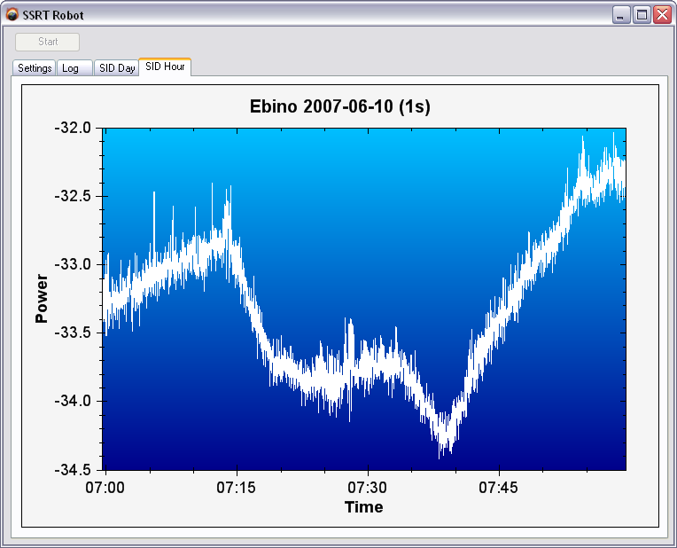The chart for the latest hour is shown here

**Blank page**

# 10. Optimizing the performance of the radio telescope

Congratulations on everything you’re achieved so far. Building the SSRT and installing it has been a challenge across many dimensions: understanding the scientific concepts involved, gathering the materials, constructing an electronic circuit, perhaps using a sophisticated oscilloscope for the first time, seeking out a distant radio signal, configuring and using new software. It’s no small achievement.

Although I’ve explained how to build and install the SSRT in one linear sequence, it’s more likely that you’ll need to be a little iterative in trouble shooting and optimizing the radio telescope’s performance. Here are some of the key issues that you may want to consider as you fine tune the setup

* Choice of VLF transmitter. There may be more than one VLF transmitter within your range, especially if you are based in Europe. It may be worth testing alternative signals to see which is best. Ideally you’ll want a signal that you can receive clearly and which shows a clear diurnal pattern due to ionosphere effects
* Tuning of the antenna. Ordinarily, with a good and clear VLF signal you’ll only need to tune the antenna within a couple of hundred Hz of the signal frequency. On the other hand, if the signal is rather weaker, then it can pay off to use small size polypropylene capacitors to fine tune the antenna and see how it improves the signal as you visualize it in the Spectrum Lab waterfall diagram
* Position and orientation of the antenna. The antenna has maximum receptiveness in the plane of the loop, and this should point to the VLF transmitter that you are monitoring. Electromagnetic interference is reduced with distance from the source. For these reasons, it’s worth some trial and error repositioning and re-pointing of the antenna to optimize the strength and clarify of the VLF signal. By watching the signal on the Spectrum Lab waterfall diagram you’ll soon get a good idea what works best. One other point to note is that simply reversing the orientation of the antenna 180 degrees also changes the received power of a VLF signal.
* Control of amplifier gain. Too little gain in the amplifier and the VLF signal will not be clearly resolved by Spectrum Lab. Too much gain and you may overwhelm the soundcard ADC at night time when the signal is strong
* Elimination of compression. Too much gain, especially in the second stage of the amplifier and you may also render the amplifier susceptible to compression. Compression occurs when a strong out-of-band signal saturates the amplifier and causes a dip in the amplification of the in-band signal. These look like step functions on the VLF graph, where the signal suddenly weakens for a period and then almost instantaneously returns to normal after the interference has passed. This is also quite visible on the Spectrum Lab waterfall graph. To minimize the risk of compression, use only the first stage of the dual amplifier to provide the needed gain, and turn the second stage right down if possible.
* Elimination of interference. Most radio interference is local, from sources within a few hundred meters of the radio telescope. If you are suffering from bad interference then it may be worth going around the house switching on and off electrical appliances to identify the offending units. Although identification by itself won’t solve the problem, you’ll be able to start thinking about workarounds

By now I hope you’ll have a working SSRT producing daily and hourly graphs of a VLF transmission that show the clear diurnal pattern characteristic of propagation of VLF signals through the ionosphere. If you’ve used the advice I’ve given so far and you’re still not there, then please drop me an e-mail (my e-mail address is at the front of this book) and we’ll see if we can solve it together. Assuming you do have a working system, let’s move on to discuss how to interpret the graphs that you are recording.

11. Interpreting the radio telescope signal

## The ionosphere can be thought of as divided into a series of layers

In each layer there is a dynamic equilibrium between the ionization caused by solar radiation and the recombination of ions and electrons caused by collisions. The balance of the equilibrium determines the ion density within each layer.

As a rough guide, bear in mind the principal drivers of the ionization equilibrium level, as follows:

* Day / night cycle of solar radiation
* Height above the Earth’s surface  
  + At lower levels in the atmosphere the density of the atmosphere increases, which speeds electron/ion recombination
  + At lower levels in the atmosphere the ionization rate decreases since the atmosphere above absorbs a proportion of the incoming solar radiation
* Latitude  
  + At higher latitudes the ionization rate decreases with the decrease in solar radiation flux
  + At higher latitudes there are seasonal variations in ionization rate and atmospheric density

Table 10.1 illustrates the characteristics of the main layers in the ionosphere

|  |  |  |  |  |
| --- | --- | --- | --- | --- |
| Layer | Altitude | Ion density  (ions / m3) | Primary ionizing radiation | **Effect on VLF signals** |
| D | 60 – 90 km | Daytime: ~1,000  Night time: ~nil | Hard X-rays (0.1 – 1 nm) | Absorption or reflection\* |
| E | 100 – 125 km | Daytime: ~100,000  Night time:  ~10,000 | Soft X-rays  (1 – 20 nm)  Extreme UV  (80 – 103 nm) | Reflection\* |
| F | 300 – 400 km | Day and night:  ~1,000,000 | Extreme UV  (20 – 80 nm) | Reflection\* |

\* Reflection is actually the result of cumulative refractions through regions of increasing electron density

Table 10.1 Ionosphere layers and their typical properties

## The distinctive outline of the trace is caused by the daily appearance and disappearance of the D layer

During the night time the D layer is absent and VLF signals are reflected by the E and F layers. This gives rise to the often very strong and stable VLF signal strength seen at night time.

As the sun rises in the upper atmosphere, incoming solar radiation starts to ionize the D layer. At this stage of the day the D layer is only weakly ionized and it now has the effect of absorbing the VLF signal almost entirely. This is what causes the dramatic decline in the VLF signal strength as seen on the daily SSRT chart at dawn.

By an hour or two after dawn the ionization of the D layer has increased enough that it is now able to reflect the VLF signal. However the reflection is not as strong as the night time reflection by the E and F layers because the lesser ionized D layer also continues to partially absorb the signal. The result as seen on the received VLF signal chart is that the signal power increases again, but to less than its former night time level.

As the sun rises towards noon, the general pattern is for a continued rise in signal strength due to the increasing ionization of the D layer.

There are further modulations during the day caused by shifting layers within the D layer. The D layer is very broad and VLF signals will be taking multiple paths between the transmitter and receiver. Since the wavelength of a typical VLF signal is about 15 km, the effect of taking multiple paths through the ~30 km wide D layer is that signals at the receiver will arrive in and out of phase with each other. This creates constructive and destructive interference that further changes the net strength of the received signal.

## Solar storms cause sudden rises (or dips) in the signal

During a solar storm the flux of the hard X-rays that ionize the D layer may increase 100 fold. This has the effect of sharply increasing the electron density and the reflection of the VLF signal, which is seen as a signal spike on the SSRT chart. After 15 or 20 minutes the electron density and the VLF signal strength will fall again thanks to the recombination of electrons and ions in the relatively dense D layer and equilibrium is restored.

(Occasionally solar flares have also been observed to cause dips in the power of the received signal, but the mechanism for this is not as well understood.)

The incidents are known as sudden ionospheric disturbances (SID’s). It is often helpful to validate an apparent SID by checking its timing against satellite measurements of actual solar X-rays. The Space Environment Centre of the US National Weather Service has charts of solar X-rays and lots of other useful information <http://sec.noaa.gov/index.html>. SSRT Robot 2 produces solar X-ray charts from GOES satellite data for comparison with your VLF signal readings.

Figures 10.1 through 10.4 illustrate some powerful SID’s that occurred in June 2007 and were received by my own solar storm radio telescope.

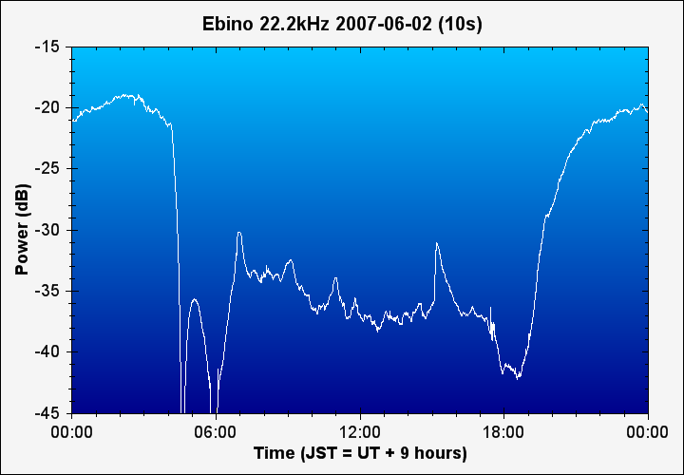

Fig 10.1

SSRT chart

showing sudden ionospheric disturbances (SID’s)

Fig 10.2

Solar X-ray chart

confirming that the SID’s were caused by solar flares

# 2007-06-02-GOESday

# 2007-06-03-SIDday

Fig 10.3

SSRT chart

showing SID’s

# 2007-06-03-GOESdayBlank page

Fig 10.4

Solar X-ray chart

confirming that the SID’s were caused by solar flares

# 12. The SSRT online network

## Sharing your observations

You may want to share your SSRT observations as part of the international network of individuals who already monitor solar activity and publish their results.

The Solar Storm Radio Telescope ("SSRT") network is a worldwide collaboration between amateur radio telescope operators monitoring Sudden Ionospheric Disturbances.

<http://www.radiotelesopebuilder.com/network.htm>

The website provides access to real time and archive data from the participating radio telescopes. A series of interactive maps can be navigated to survey the network. A brief key is given below.

 These symbols depict the VLF transmitters. Mouse over the symbols to identify the transmitters and the frequencies on which they transmit.

These symbols depict the SSRT radio telescopes. Mouse over to identify each station and check which transmitters it monitors (yellow lines). Click on a station to bring up real-time data in thumbnail format. Click on the chart thumbnails, or double click on the symbol itself to navigate to a full scale chart with archive access.

If you are interested to join the network once your radio telescope is up and running then please e-mail me at [percival.andrews@gmail.com](mailto:percival.andrews@gmail.com) and attach the following items:

* An example day graph produced by SSRT Robot
* An example waterfall chart screenshot from Spectrum Lab
* A completed registration file, as included in the SSRTRobot2.zip folder (“SSRT network registration.txt”)

There is no charge to users.

**Blank page**

# 13. Keeping a record

Now that you have an operational radio telescope monitoring the Sun it’s a good idea to keep a record of what it detects in a small notebook. Over the months and years you’ll build up a history of events that are unique to you and your telescope. Some of the questions you may want to think about as you build up your records are:

* What is the minimum sensitivity of your SSRT to solar flares? (I.e. what is the smallest flare that it can detect?)
* What is the effect of Coronal Mass Ejections (CME’s) on VLF signal transmission?
* Is it possible to detect major Gamma Ray Bursts (GRB’s) with the SSRT at night time?
* How reliable are the indicators of forthcoming solar activity (sunspots, space weather forecasts, etc)?
* How is the solar cycle progressing?

If you want to go further the American Association of Variable Star Observers AAVSO has a program for solar observers monitoring SID’s. Their website has the details how to apply, and appendix 5 of this book shows how to modify the SSRT’s data collection procedures to best suit the AAVSO’s requirements <http://www.aavso.org/observing/programs/solar/>.

**Moving on to new radio telescope projects**

The SSRT may just be the start of several projects in radio astronomy for you. Some other possible projects include:

* Monitoring radio bursts from Jupiter at 20 MHz. NASA’s Radio Jove project has more details.
* Listening to shortwave scatter produced by incoming meteors. The American Meteor Society has further details
* There are even dedicated amateurs listening to pulsars with home-built equipment.

## Conclusion

I hope you have enjoyed building your own Solar Storm Radio Telescope. It’s a fairly unique hobby to build and operate one of these instruments.

Thank you also for purchasing my SSRT e-book. If you have any questions or comments about this book, or would simply like to get in touch, then my e-mail address is in the front of this book. I look forward to hearing from you.

**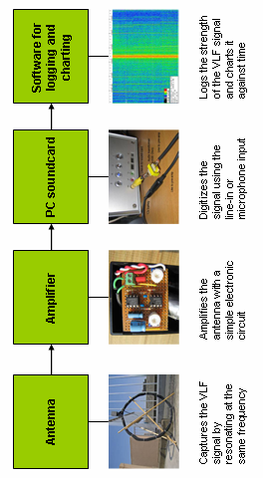**A1. SSRT System diagramA2. Electronic schematic diagram

# A3. Electronics parts listA4. Signal generator

If you do not have a signal generator built into your oscilloscope you can make this simple Wien-bridge oscillator using the same type of op-amp IC that is used for the SSRT. To use the oscillator, adjust R6 and R7 in parallel until the sine wave output is at the frequency desired, as measured with the oscilloscope.

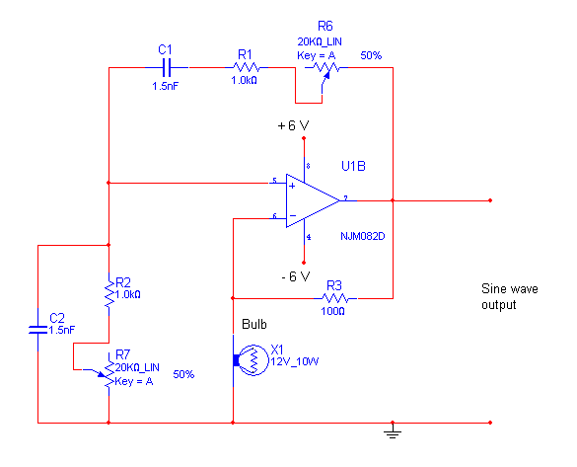The frequency, **f** /Hz, of the sine wave output is given by:

**f = 1 / (2 \* pi \* R \* C)** [Eq. A4.1]

where

**R** = (R2 + R7) = (R1 + R6)

**C** = C1 = C2

The circuit with the component values shown will oscillate from about 5 kHz to beyond 30 kHz. Use a 12V supply to provide +/- 6V. The exact specification of the bulb is not too critical provided the voltage is within range.

# A5. Data collection for the AAVSO’s SID program

The following adjustments to the data collection procedures are recommended for observers wishing to join the AAVSO’s monitoring program. Michael Hill [noatak@aol.com](mailto:noatak@aol.com), Chairman of the AAVSO SID Group, has kindly developed and contributed this approach for the benefit of AAVSO observers.

Many AAVSO observers are using a shareware software package called SIDGraph, which was written by one of the AAVSO’s members. The advantage of this software is that it presents SID events directly in the appropriate format for cataloguing by the AAVSO. SIDGraph requires that the data format is a series of lines that include the time and output level, like this:

08:35:22 3.456

You should make the following changes in order to have Spectrum Lab output in this format:

1. **Figure 8.7**   
   The equation for the signal should be modified to make the output data a positive number as if it were a voltage. This is done by dividing the output (in dB) into a signal level base (in dB) so for example:   
     
   **ebino22200 = -120/avrg(22140,22260)**  
   The value (-120 in this case) is arbitrary, and should be chosen so the daily output level covers a range of 1 to 5
2. **Figure 8.8**  
   File Contents tab  
   Set number of columns to 7; Set column separator to 32; No titles in any column  
   Col 1 – No expression; Format = #  
   Col 2 – Expression = t+18000; Format = hh:mm:ss  
   Col 3-6 – No expression; Format = #  
   Col 7 – Expression = Ebino22200; Format = ##0.00#  
     
   Notes: (i) 18000 in expression for t is to convert EST to Universal Time (UT). Adjust for your time zone. (3600 seconds per hour difference in time). (ii) The expression identifiers vary depending on what you set them to in Filename & Activation tab.  
   Filename and Activation tab  
   Check “use write interval” ON  
   Set interval to 15 seconds
3. **Figure 8.9**  
   The format for the filename must be modified as follows:   
     
   export.start(“c:\\My Documents\\Astronomy\\Radio Telescope\\DataFiles\\xxx\_”+str(“MMDD”,now)+”.DAT”)  
     
   Where xxx = 3 letter designation of station being monitored, e.g. NAA.  
     
   Adjust the folder and subfolders as required, but keep the file name format unchanged.